**Question – 1 Write a C++ program to print Hello MySirG on the screen.**

**Ans.**

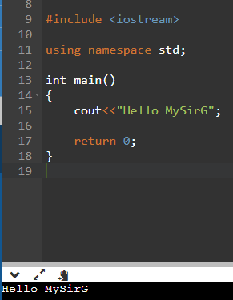

**Question – 2 Write a C++ program to print Hello on the first line and MySirG on the second line using endl.**

**Ans.**

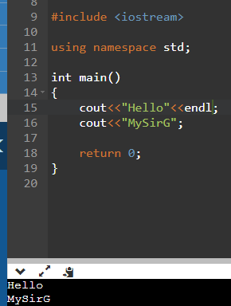

**Question – 3 Write a C++ program to calculate the sum of two numbers.**

**Ans.**

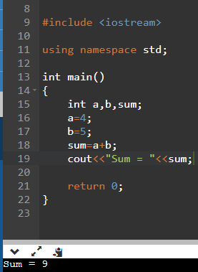

**Question – 4 Write a C++ program to calculate the area of a circle**

**Ans.**

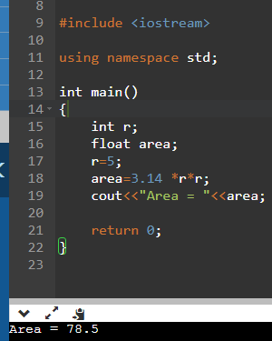

**Question – 5 Write a C++ program to calculate the volume of a cuboid.**

**Ans.**

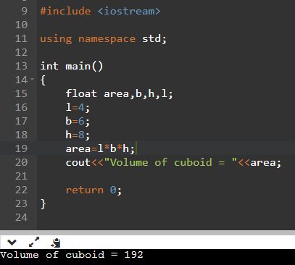

**Question – 6 Write a C++ program to calculate an average of 3 numbers.**

**Ans.**

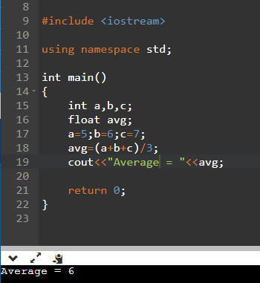

**Question – 7 Write a C++ program to calculate the square of a number.**

**Ans.**

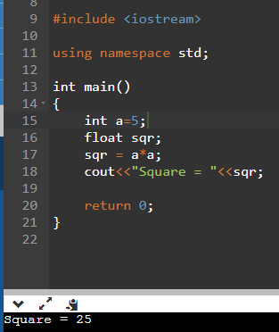

**Question – 8 Write a C++ program to swap values of two int variables without using third variable.**

**Ans.**

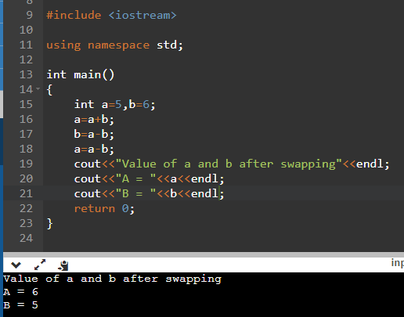

**Question – 9 Write a C++ program to find the maximum of two numbers.**

**Ans.**

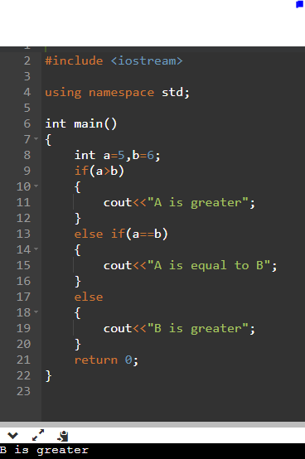

**Question – 10 Write a C++ program to add all the numbers of an array of size 10.**

**Ans.**

